What’s [ SQL | MySQL | MySQLi | PDO ]
SQL = Structured Query Language
MySQL = Relational Database Management System
MySQL has Extensions to connect To DB (PDO, MySQLi , …)
[mysql_connect] : old func
[mysql_query] : old func
[mysql_*] : old funcf
Deprecated => PHP 5.5
Removed => PHP 7.0.0
New extension:
PDO => PHP Data Object
SQLi => i for improved
SQL => language .
Imagine MySQL is a book , and we use extension to access the book and read from it .

Intro
- MySQL Created by Swedish Company & Now owned by Oracle.
- MySQL is Popular For Web Application
- MySQL is Free
- MySQL is Open Source
- MySQL is Easy To Use
- MySQL Use SQL Standard
- MySQL is [RDBMS] Relational Database Management System.
- MySQL is used in wordpress , facebook, joomla……
To see all examples of mysql customers, search : https://www.mysql.com/customers/

Tools or methods to access our mysql db

Command line
To connect to mySql Db , open you command line:
Mysql -u root -p
If mysql in not regenozid , open environement modify path , and then new :
If you're using XAMPP, the path to add is:
C:\xampp\mysql\bin
If MySQL is installed separately, the typical path would look like:
C:\Program Files\MySQL\MySQL Server <version>\bin
• Add to Environment Variables:
- Press Windows + S, type "Environment Variables", and select "Edit the system environment variables".
- In the System Properties window, click "Environment Variables".
- Under System variables, find the variable named Path and click Edit.
- Click New, and paste the path to the bin folder.
- Click OK to close all windows.
• Verify:
- Open a new terminal and type:
mysql --version
If it's set up correctly, it will show the installed MySQL version.
So le’s understand , how to connect and to specify the port.
So why we want to change the port.

PHPmyAdmin
What is phpMyAdmin?
phpMyAdmin is a web-based tool that helps you manage MySQL databases easily. It provides a user-friendly interface to create, edit, delete databases, run queries, and manage users without needing to use the command line.
Queries for Testing:
- Show all databases:
SHOW DATABASES;
- Create a database:
CREATE DATABASE testdb;
- Drop (delete) a database:
DROP DATABASE testdb;
Just for test, example : add or remove db, and then verify in cli , or vice versa:

MySQL Workbench
What is MySQL Workbench?
MySQL Workbench is a visual tool for database management that allows you to interact with MySQL databases. It provides features to design, query, and manage databases, as well as tools for database administration, data modeling, and server configuration—all through a user-friendly graphical interface. It helps simplify tasks like creating databases, writing SQL queries, and managing users.

Syntax & some info
Whene we enter Phpmyadmin , no we login into it. But without password, because there is no password specified in confing.inc.php
There is an example, of it, I heilight the password yellow :
* cookie
*/
$cfg['blowfish_secret'] = 'your_secure_secret'; /* Change this for more secure cookie auth */

/*
* Servers configuration
*/
$i = 0;

/*
* First server
*/
$i++;

/* Authentication type and info */
$cfg['Servers'][$i]['auth_type'] = 'config'; // Use 'config' for default user/pass or 'cookie' for user login
$cfg['Servers'][$i]['user'] = 'root'; // MySQL username
$cfg['Servers'][$i]['password'] = ''; // MySQL password is empty
$cfg['Servers'][$i]['extension'] = 'mysqli'; // MySQL extension
$cfg['Servers'][$i]['AllowNoPassword'] = true; // Allow login without password

/* Bind to the localhost ipv4 address and tcp */
$cfg['Servers'][$i]['host'] = '127.0.0.1'; // localhost IP address
$cfg['Servers'][$i]['connect_type'] = 'tcp'; // TCP connection

/* Update the port here */
$cfg['Servers'][$i]['port'] = '3307'; // MySQL port

$cfg['Servers'][$i]['controluser'] = 'pma'; // phpMyAdmin control user
$cfg['Servers'][$i]['controlpass'] = ''; // phpMyAdmin control password (if needed)

/* Advanced phpMyAdmin features */
$cfg['Servers'][$i]['pmadb'] = 'phpmyadmin'; // phpMyAdmin database
$cfg['Servers'][$i]['bookmarktable'] = 'pma__bookmark'; // Bookmarks table
$cfg['Servers'][$i]['relation'] = 'pma__relation'; // Relations table
$cfg['Servers'][$i]['table_info'] = 'pma__table_info'; // Table info
$cfg['Servers'][$i]['table_coords'] = 'pma__table_coords'; // Table coordinates
$cfg['Servers'][$i]['pdf_pages'] = 'pma__pdf_pages'; // PDF pages
$cfg['Servers'][$i]['column_info'] = 'pma__column_info'; // Column info
$cfg['Servers'][$i]['history'] = 'pma__history'; // History table
$cfg['Servers'][$i]['designer_coords'] = 'pma__designer_coords'; // Designer coordinates
$cfg['Servers'][$i]['tracking'] = 'pma__tracking'; // Tracking table
$cfg['Servers'][$i]['userconfig'] = 'pma__userconfig'; // User config
$cfg['Servers'][$i]['recent'] = 'pma__recent'; // Recent tables
$cfg['Servers'][$i]['table_uiprefs'] = 'pma__table_uiprefs'; // Table UI preferences
$cfg['Servers'][$i]['users'] = 'pma__users'; // Users table
$cfg['Servers'][$i]['usergroups'] = 'pma__usergroups'; // User groups
$cfg['Servers'][$i]['navigationhiding'] = 'pma__navigationhiding'; // Navigation hiding
$cfg['Servers'][$i]['savedsearches'] = 'pma__savedsearches'; // Saved searches
$cfg['Servers'][$i]['central_columns'] = 'pma__central_columns'; // Central columns
$cfg['Servers'][$i]['designer_settings'] = 'pma__designer_settings'; // Designer settings
$cfg['Servers'][$i]['export_templates'] = 'pma__export_templates'; // Export templates
$cfg['Servers'][$i]['favorite'] = 'pma__favorite'; // Favorite queries

/*
* End of servers configuration
*/
?>
Or you can find the next path : C:\xampp\phpMyAdmin\config.inc.php
User : root
Password = “ “ ------meaning it’s empty
/* Authentication type and info */
In this section you gonna fine , username & password
λ mysql -u root -p
Enter password: *****
Welcome to the MySQL monitor. Commands end with ; or \g.
Your MySQL connection id is 32
Server version: 8.0.40 MySQL Community Server - GPL

Copyright (c) 2000, 2024, Oracle and/or its affiliates.

Oracle is a registered trademark of Oracle Corporation and/or its
affiliates. Other names may be trademarks of their respective
owners.

Type 'help;' or '\h' for help. Type '\c' to clear the current input statement.

mysql> quit
Bye

We use quit to close connection
Note : CREATE DATABASE IF NOT EXISTS BILAL;
DROP DATABASE IF EXISTS mohsin;
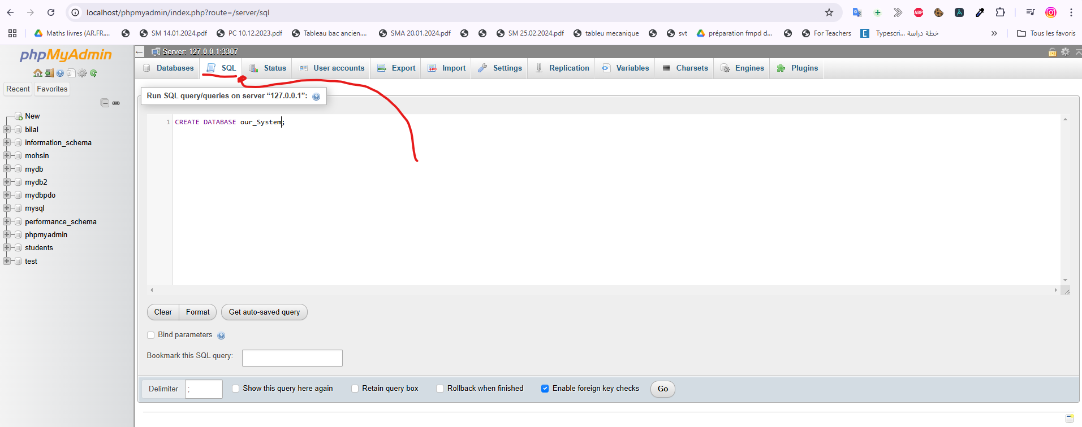
²The same queries that we did in cli and mysql workbench we can do them, we can do in phpmyadmin, by clicking on sql .

Note: Sql keyword is always have different color, to separate language keywords from normale name or …
Now focus pls :
Every thins you do it , in phpmyadmin you can see the command to do it the CLI ; or the php query
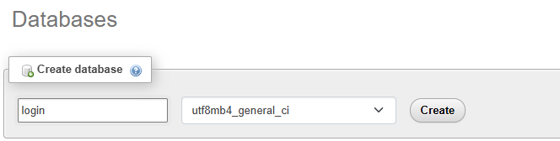

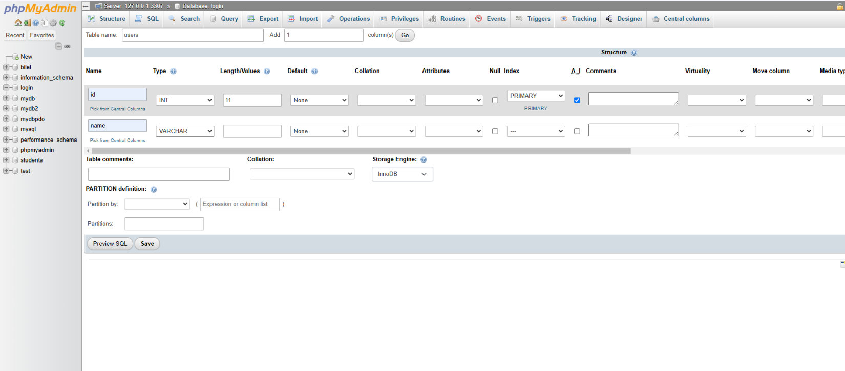
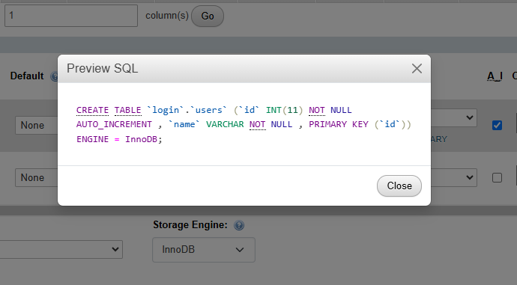
And also when you click on any thing you get the command auto in screen , example :
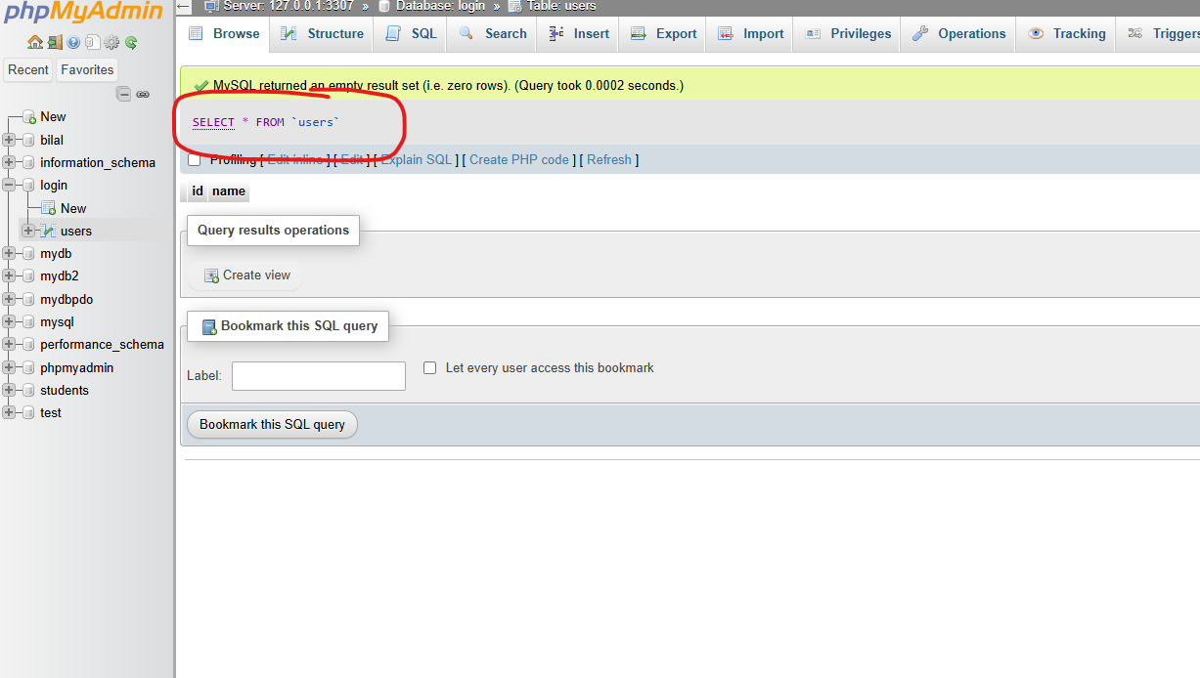
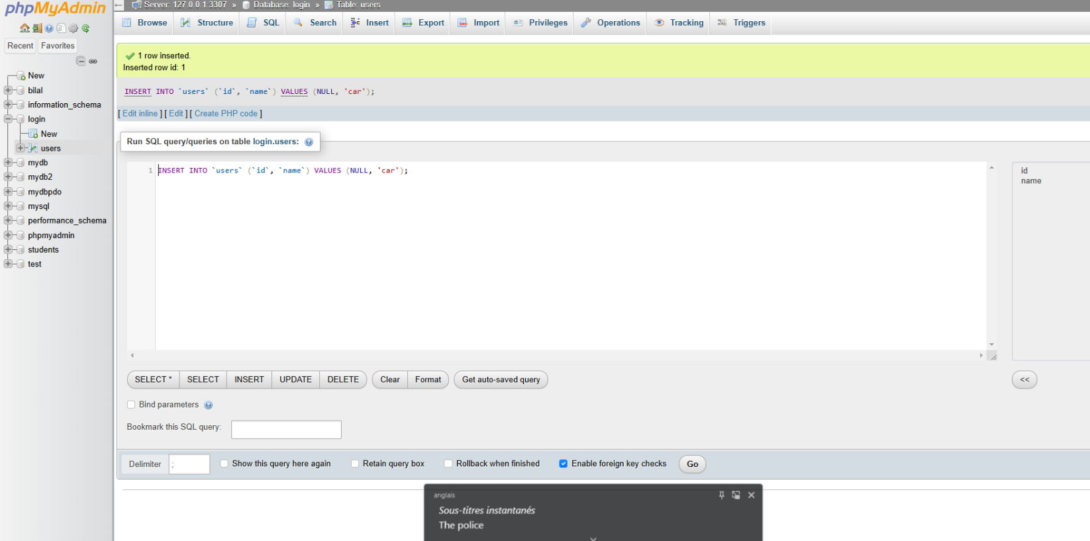

To insert info, first select table, and click insert :
Or you can create php code from
We can copy query and test it in phpmyadmin , cli and mysql workbench , just change name value.
Mysql workbench
Use login;
INSERT INTO `users` (`id`, `name`) VALUES (NULL, 'ps3');
phpmyadmin
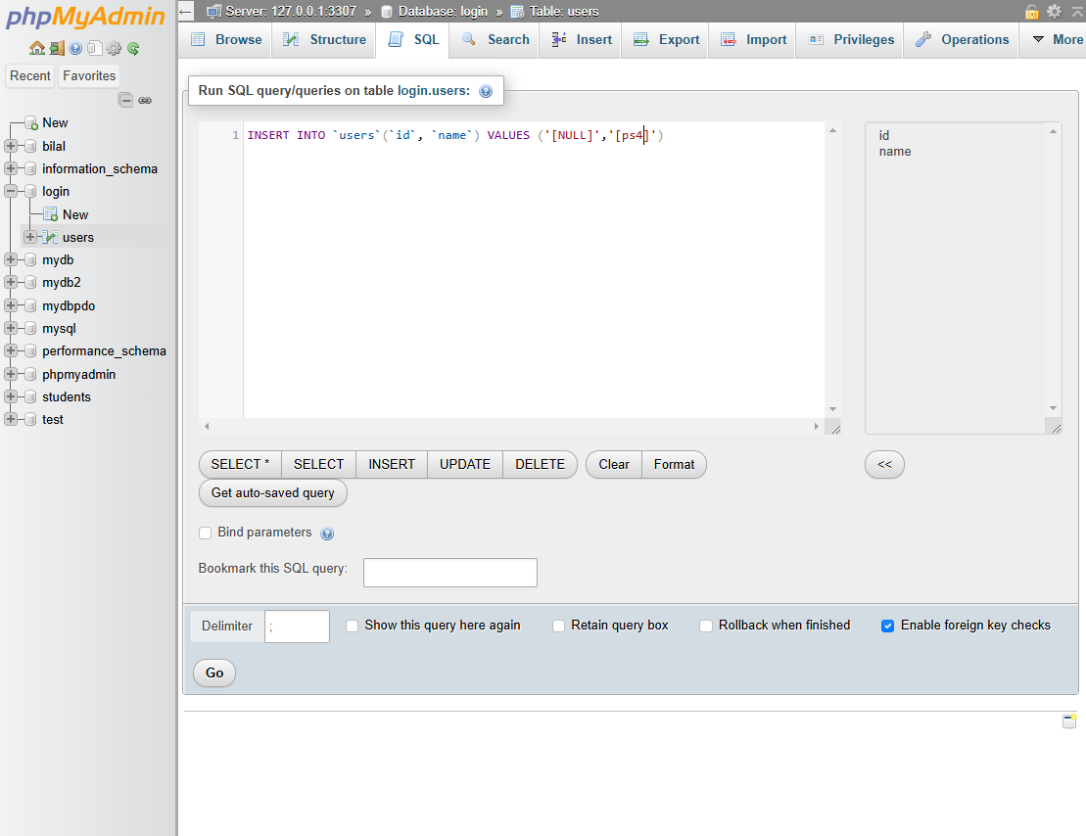
And also there is some tools that can help you , it give the syntax : 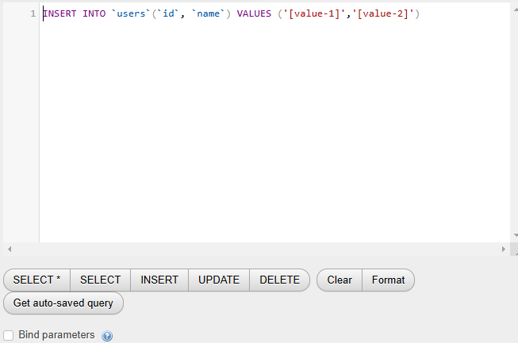
All you have to do, is replacing.
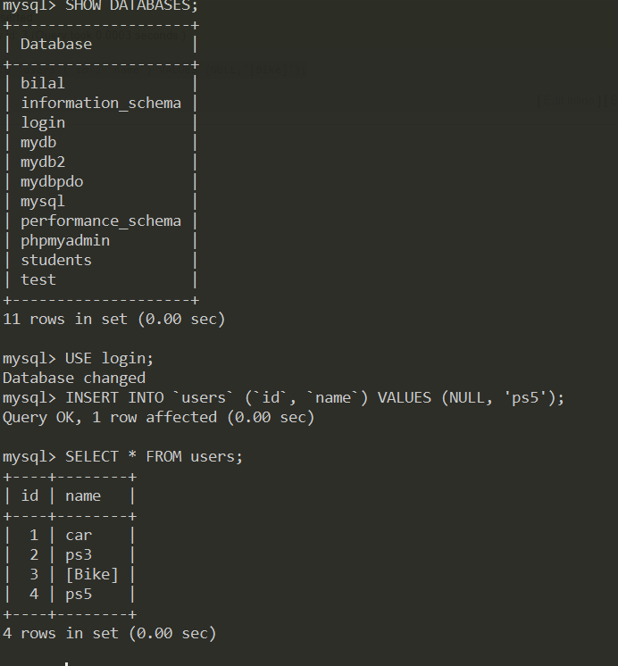

Connect With PDO + Examples
PLS focus there some very important infos:
// dsn = data source name

$dsn = "mysql:host=localhost;dbname=login;port=3307";
$user = "root"; // the user to connect
$pass = ""; // the password of this password

// PDO supports exception handling
// try => try to do something, that could throw an exception
// catch => catch the exception and handle it

try {

$connection = new PDO($dsn, $user, $pass); // Start a new connection with PDO class
$query = "INSERT INTO products (id, name) VALUES (NULL, 'iPhone 6')"; // SQL query
$connection->exec($query);

echo "You Are Connected";

} catch (PDOException $e) {

// PDO has a class called PDOException that handles exceptions
// if it not exit, i have to write the exception in try

echo "Failed ". $e->getMessage();
// getMessage() returns the error message more specific than the error code return by command line
}

Attribute
In PHP PDO (PHP Data Objects), attributes are settings or options that control the behaviour of the PDO connection and statement. You can use attributes to configure how PDO works, such as error handling, fetch modes, timeouts, etc.
$connection -> setAttribute(PDO::ATTR_ERRMODE, PDO::ERRMODE_EXCEPTION);

Note :
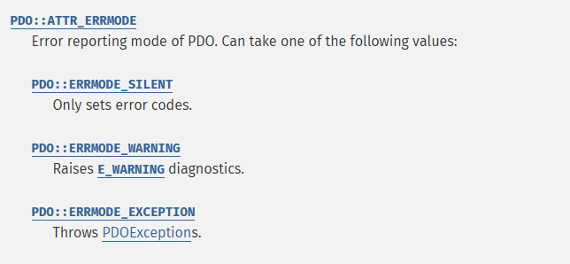
To get info of any attribute, just google it , and go to php.net manual
Imagine that we have to add a product name in arabic.
/ dsn = data source name

$dsn = "mysql:host=localhost;dbname=login;port=3307";
$user = "root"; // the user to connect
$pass = ""; // the password of this password
$options = array(
// set the encoding
PDO::MYSQL_ATTR_INIT_COMMAND => "SET NAMES utf8mb4"
// note : PDO::MYSQL_ATTR_INIT_COMMAND is used
);

// PDO supports exception handling
// try => try to do something, that could throw an exception
// catch => catch the exception and handle it

try {

$connection = new PDO($dsn, $user, $pass, $options); // Start a new connection with PDO class
$query = "INSERT INTO products (id, name) VALUES (NULL, 'هاتف 3')"; // SQL query
$connection->exec($query);

echo "You Are Connected";

} catch (PDOException $e) {

// PDO has a class called PDOException that handles exceptions
// if it not exit, i have to write the exception in try

echo "Failed ". $e->getMessage();
// getMessage() returns the error message more specific than the error code return by command line
}

The PDO::MYSQL_ATTR_INIT_COMMAN attribute in PDO is used to execute an SQL command immediately after establishing a connection to MySQL database. It is often used to configure the connection environment, such as setting the character set or initializing specific settings for the session.
$options = [
PDO::MYSQL_ATTR_INIT_COMMAND => "SET NAMES 'utf8mb4'", // Set character set
PDO::ATTR_ERRMODE => PDO::ERRMODE_EXCEPTION, // Enable exceptions on error
];
This command ensures that the connection uses the utf8mb4 character set, which supports a wider range of Unicode characters (e.g, emojis).
Tips:
- Always use PDO::ERRMODE_EXCEPTION for better debugging.
- Use PDO::FETCH_ASSOC to fetch rows as associative arrays for easier access to data by column names.

Summary
By using PDO::MYSQL_ATTR_INIT_COMMAND, you can ensure that your connection is preconfigured for optimal (best ) functionality, avoiding the need to execute additional commands in your code later.

Data Type – Numeric

Data Type Name | Storage | Signed Range | Unsigned Range | Max  Charcters
Tinyint | 1 byte | -128 to 127 | 0 to 255 | 3
Smallint | 2 bytes | -32,768  to  32,767 | 0 to 65,535 | 6
Mediumint | 3 bytes | -8,388,608  to  8,388,607 | 0 to 16,777,215 | 9
Int (Integer) | 4 bytes | -2,147,483,648  to  2,147,483,647 | 0 to 4,294,967,295 | 10
Bigint | 8 bytes | 9,223,372,036,854,775,808  to  9,223,372,036,854,775,807 | 0  to  18,446,744,073,709,551,615 | 20
How to get this info :
- Storage & signed & unsigned range : hovering on data type in phpmyadmin
- Max characteres: click on structure in the nav above you see: ex : bigint(20), but don’t specify the length manualy

=============================== MySQL Datatype =================================

INT

  - INT Max Length
- The maximum length (11) you see in INT (11) does not affect the range or storage size of the integer. It is only for display width when using ZEROFILL attribute
- Without ZEROFILL, INT (11) behaves the same as INT .

  - INT Max Range
- Storage Size : 4 bytes (32 bits)
- Ranges :

Type | Range
Signed | -2,147,483,648 to 2,147,483,647
Unsigned | 0 to 4,294,967,295

Explanation :
- Signed INT : includes both positive and negative numbers.
- Unsigned INT : Includes only positive numbers, so it doubles the upper range.
- Key Differences
- INT size is always fixed at 4 bytes regardless of the display width (INT (11) is still 4 bytes) .
- Use unsigned if you know the values will never be negative, allowing a larger range.
Example :
Create Table :
CREATE TABLE example (
id INT(11) UNSIGNED, -- ID cannot be negative, uses unsigned range
age INT(11) -- Age can be negative, uses signed range
);
Summary :
- Max range of INT (signed): -2,147,483,648 to 2,147,483,647
- Max range of INT (unsigned): 0 to 4,294,967,295
- Display width (e.g., 11) is only for formatting with ZEROFILL.
So the length is only for zerrofill formatting.
Note: just if you hover on datatype in phpmyadmin you gonna get the max range.
Note :
You want to clea0r the MySQL command line console. In MySQL CLI, the cls command does not work because it’s a Windows for clearing the console, not a MySQL command;
To clear the screen in MySQL, you can use the following :
- \! Command
MySQL allows you to run system commands using the \! Command. You can use this to run a system command that clears the terminal.
\! Shell command
So for clearing : \! Clear

Should type wiesly

Let make an experience now !!
So let create a database and create also a table in it, and send to it 5000 value. But using tinyint and bigint
// dsn = data source name
$dsn = "mysql:host=localhost;dbname=experiment;port=3307";
$user = "root"; // the user to connect
$password = ""; // the password of this user

$options = [

PDO::MYSQL_ATTR_INIT_COMMAND => "NAMES 'utf8mb4'", // Set character set
PDO::ATTR_ERRMODE => PDO::ERRMODE_EXCEPTION, // Enable exceptions on error
];

try {
$connection = new PDO($dsn, $user, $password);

} catch (PDOException $e) {
echo "Bad, ".$e -> getMessage();
die;
}

for ($i = 1 ; $i <= 5000; $i++) {
$stmt = $connection -> prepare("INSERT INTO `tbl` (`id`) VALUES ('5000');");
$stmt -> execute();
}
And know let see the diffrence in database size :
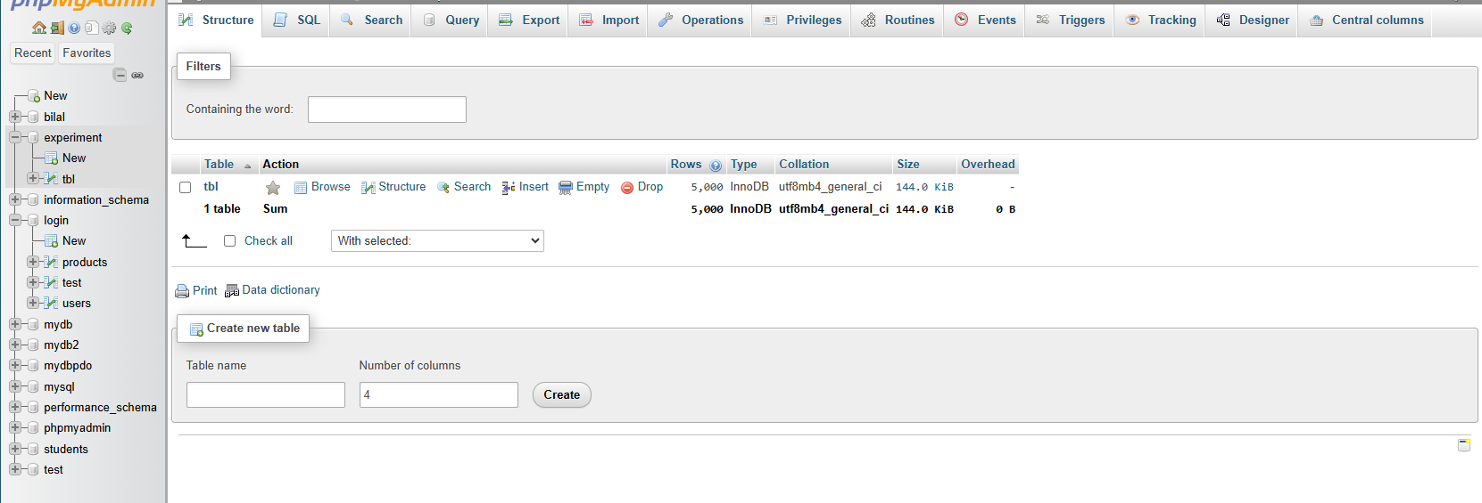
And now using bigint:
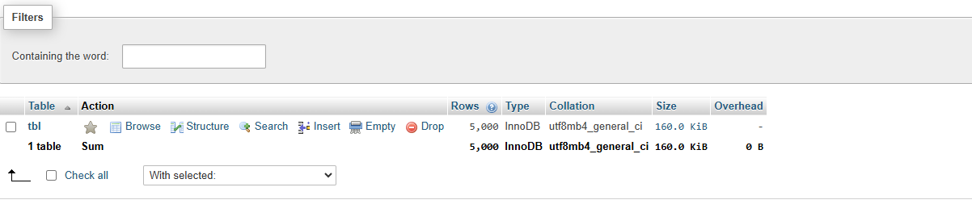

So 160kb ------------ 144kb ,
Imagine the diffrence woriking on big projects.
So use the datatype wiesly if you don’t want , the db size explose in you face hhhhhhhhhhh.

Decimals
Data Type | Description | Storage | Precesion | Range (Approx) | Use Case
DECIMAL | Fixed-point number | Varies based on precision | Exact precision defined by  (M, D ) | -10^38 +1  To  10^38 -1 | Financial and monetary data where exact precision is crucial
FLOAT | Single-precisin floating-point | 4 bytes | Approx. 7 decimal digits | ±1.5e-45  To  ±3.4e38 | Scientific calculations where approximate values are acceptable
DOUBLE | Double-precision floating-point | 8 bytes | Approx. 15 decimal digits | ±5.0e-324  to  ±1.7e308 | High-precision scientific calculations
REAL | Synonym for FLOAT (in MySQL ) | 4 bytes | Approx. 7 decimal digits | ±1.5e-45  To  ±3.4e38 | Same as FLOAT, for compatibility with other SQL databases

DECIMAL (Fixed-point number):
- Precision: Defined exactly with (M, D), where M is the maximum total number of digits and D is the number of digits after the decimal point.

Explanation of M and D:
- M (Precision):
  - Represents the total number of significant digits that can be stored, both to the left and right of the decimal point.
  - For example, in DECIMAL(10, 2), the precision is 10, which means you can store up to 10 digits in total.
- D (Scale):
  - Represents the number of digits that can be stored to the right of the decimal point.
  - For example, in DECIMAL(10, 2), the scale is 2, which means you can store up to 2 digits after the decimal point.

How M and D Work Together:
- The number of digits before the decimal point is calculated as M - D.
- In DECIMAL(10, 2), you can have 8 digits before the decimal point and 2 digits after the decimal point.
Examples:
- DECIMAL(5, 2):
  - Precision (M): 5 digits in total.
  - Scale (D): 2 digits after the decimal point.
  - Values: Can store numbers like 123.45, 12.34, and -123.45.
    - Maximum value: 999.99
    - Minimum value: -999.99

Summary:

- DECIMAL is best for storing fixed-point numbers with exact precision, ideal for financial applications.
- FLOAT and REAL (in MySQL) are used for single-precision floating-point numbers, suitable for scientific calculations where exact precision is less critical.
- DOUBLE provides double-precision and is used for high-precision calculations.

Other numeric types

Data Type Name | General Category | Description | Storage | Typical Values | Use Case
BIT | Integer data type | Stores binary data (0,1) | 1 bit | 0 , 1 | Binary flags, true/false
BOOLEAN | Integer data type | Alias for TINYINT(1) | 1 byte | TRUE, FALSE ( 1 , 0 ) | Logical true/false conditions
SERIAL | Numeric data Type | Auto-incrementing integer | 4 bytes | 1 , 2 , 3 ….. | Primary keys, unique identifiers

Detailed Descriptions:
- BIT:
  - General Category: Integer Data Type
  - Description: Stores binary data, typically representing 0 and 1.
  - Storage: 1 bit per value.
  - Typical Values: 0, 1.
  - Use Case: Ideal for storing simple binary flags, such as true/false or yes/no statuses.
- BOOLEAN:
  - General Category: Integer Data Type
  - Description: In MySQL, BOOLEAN is an alias for TINYINT(1), storing 0 (false) and 1 (true).
  - Storage: 1 byte per value.
  - Typical Values: TRUE (1), FALSE (0).
  - Use Case: Commonly used for logical conditions and boolean flags.
- SERIAL:
  - General Category: Numeric Data Type
  - Description: An alias for BIGINT UNSIGNED NOT NULL AUTO_INCREMENT UNIQUE, used for auto-incrementing integers.
  - Storage: 4 bytes per value.
  - Typical Values: Auto-incrementing sequence, such as 1, 2, 3, ....
  - Use Case: Frequently used for primary keys or unique identifiers in database tables.
Note:

Binary Flags :
Binary flags are a way to represent diffeent states or conditon using binary values (0 and 1). Each bit in a binary flag represents a distinct condition or state. Thery are commonly used in programming and databases to efficiently sotre and manipulate multiple boolean condtions using bitwise operations : عمليات بتية

Examples and Use Cases:
- User Permissions:
  - In a system with multiple permissions (e.g., read, write, execute), you can use a binary flag to represent the permissions.
  - Example: 101 (binary) could represent Read and Execute permissions (1 for true/active, 0 for false/inactive).
- Feature Toggles:
  - Binary flags can be used to enable or disable features in an application.
  - Example: 011 might indicate that two out of three features are enabled.
- Status Indicators:
  - Representing multiple status indicators (e.g., active, pending, disabled) within a single integer using binary flags.
  - Example: 0010 could mean an account is pending.

Data Type – Date & Time

Data Type ---- String

Char & Varchar

Char => Character
- Store Fixed Value
- Max Character 255
- Faster Than VarChar 50%
- Use Static Memory

VarChar => Variable Character
- Store Variable Value .
- Max Ch 65,535
- Slower Than VarChar
- Use Dynamic Memory

Let prove by adding infos to fields one varchar and other char .
First : char (255)
So here the system reserve 255, although I use it or not.
So, it better to specify the length that exactly you gonna use it.
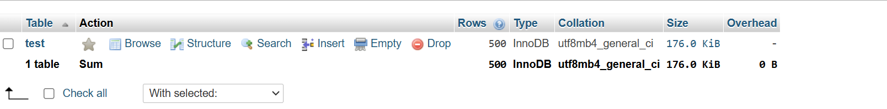

Now , let’ s use varchar :
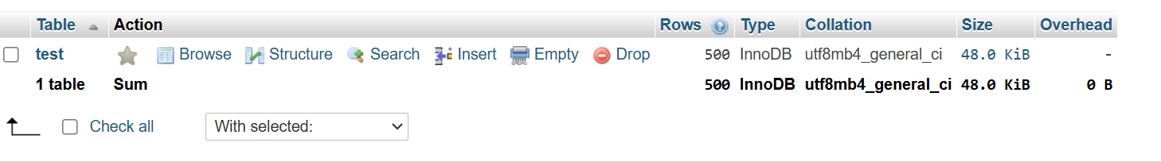
So the diffrecne is so big and clear , so :
So char when you reserve is done, you pay . but varchar is dynamic.
So If you know the the exact length of character, it soo so better to use char , because it use static memory and it faster 50% Than varchar.
But if not : it better to use varchar to preserve memory.

Note : MySQL 8.4, the maximum length for a VARCHAR column is 65,535 characters. However, the actual maximum length can be less depending on the character set used and the maximum row size1. For example, if you're using utf8mb3 (which can require up to three bytes per character), the maximum length would be around 21,844 characters.

Text & BLOB

Text => Store String
- Deal & Compared Depend on Charset
- Sotre long Strings.

BLOB => Binary Large Object
- Has no Charset
- Dela & compared ON Numer value of the Bytes
- Use to Store Images & other files .

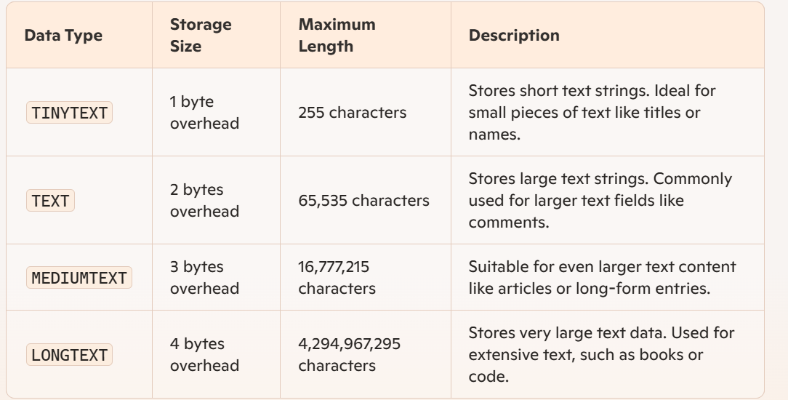

So as we know the big thing are very expensive .

Enum
The ENUM type in MySQL is used to specify a column that can have one of a predefined set of values. Tjis is prticulary useful for columns that should only contain a limited set of options, such as statuses or categories.

Using ENUM in Table Creation :
Let’s create a table for storing user profiles with a status column that can only have specific values.
Step-by-step Example :
- Define the ENUM column :
- When Creating the table, define te ENUM column with the allowed values
- Insert Values :
- Insert rows with valid ENUM values .
- Query and Filter :
- Query the table and filter specificc ENUM values
This the sql script :

CREATE TABLE user_profiles (
id INT AUTO_INCREMENT PRIMARY KEY,
username VARCHAR(50) NOT NULL,
email VARCHAR(100),
status ENUM('active', 'inactive', 'suspended', 'pending') NOT NULL
);
Whene you specify ENUM type, “Edit ENUM SET values” for adding the options

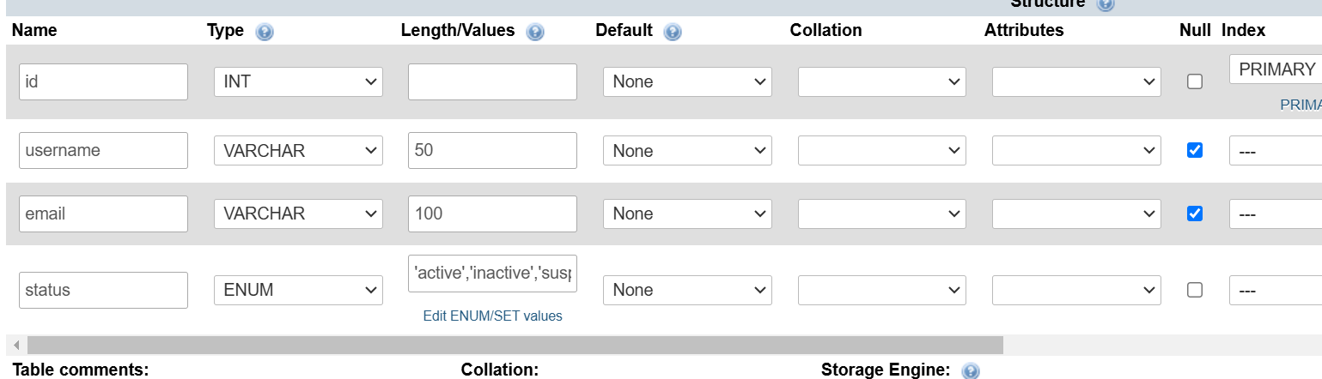

The here you can add, you options :
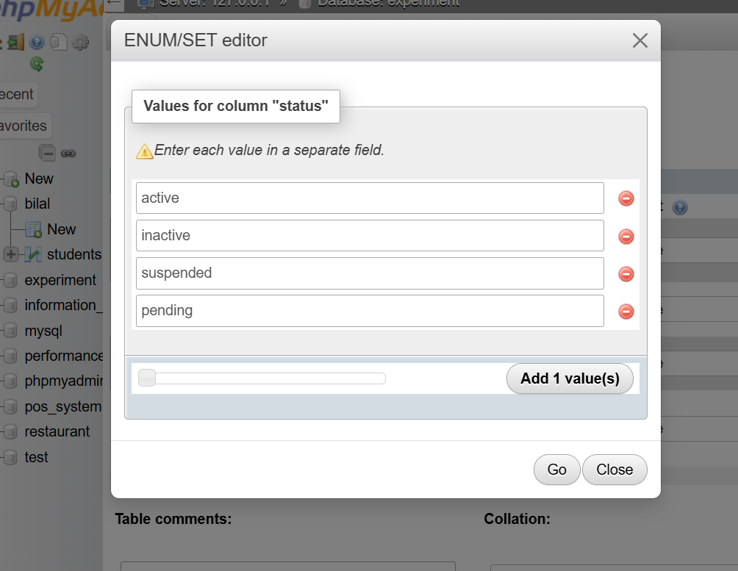
Then press “Go”
Now let’t try to insert some values:
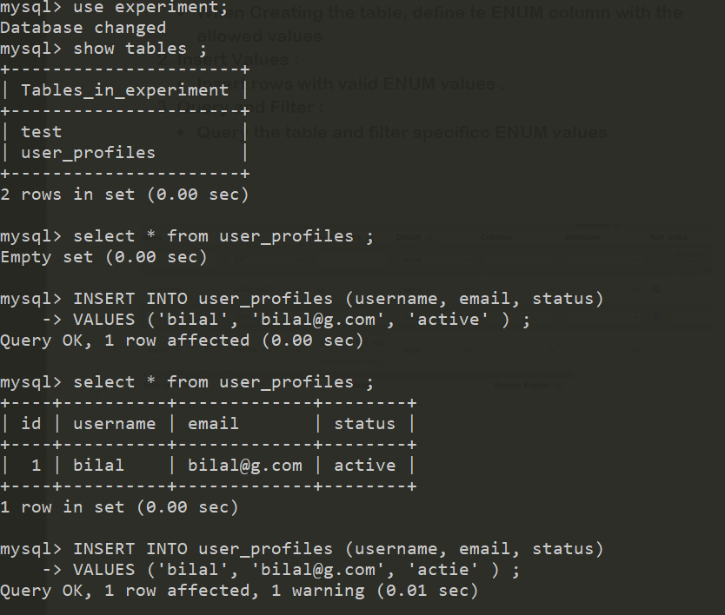
As you have see, i get an warning, when I try to insert a value in status , that doesn ‘t extit in ENUM set .
Brief , Enum is like a box that you can choose one value from, but imagine that you want to mak the user able to chose more than one value , let say 3 values from the box ( that contain by example 10 values ) .
So here you have to use SET

SET
A SET in MySQL is a data type used to store multiple values in a single column, each of which must be chosen from a predefined list.

Key Points About SET

- Multiple Values : Unlike ENUM, a SET can store zero or more values from a predefined list.
- Predefined List : You define the possible values when you create the table.
- Example Use Cases : Storing multiple hobbies, tags, categories, or permissions.

Suppose you want to store a list of hobbies for users, where each user can have multiple hobbies.
CREATE TABLE users (
id INT AUTO_INCREMENT PRIMARY KEY,
name VARCHAR(100),
hobbies SET('Reading', 'Traveling', 'Swimming', 'Gaming')
);

INSERT INTO users (name, hobbies)
VALUES ('Alice', 'Reading,Swimming'),
('Bob', 'Traveling,Gaming'),
('Charlie', 'Reading,Traveling,Swimming,Gaming');

SELECT * FROM users;

In this example:
- Column Definition: The hobbies column can contain any combination of the values 'Reading', 'Traveling', 'Swimming', and 'Gaming'.
- Inserting Data: When inserting data, you can specify multiple values separated by commas.
- Querying Data: You can retrieve the data just like any other column.
Benefits:
- Flexibility: Useful for fields where multiple selections are valid.
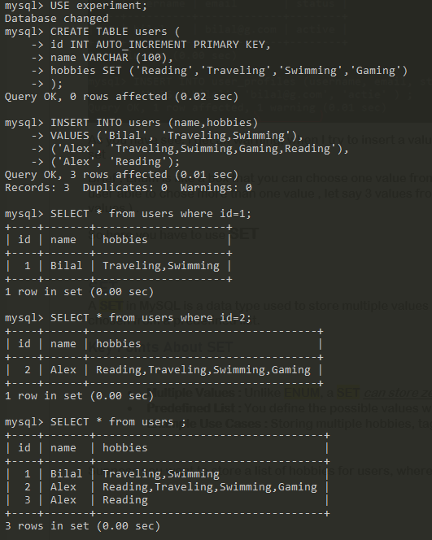
- Storage: Efficient storage compared to using multiple boolean columns.
As you see, this how the img looks from phpmyadmin :
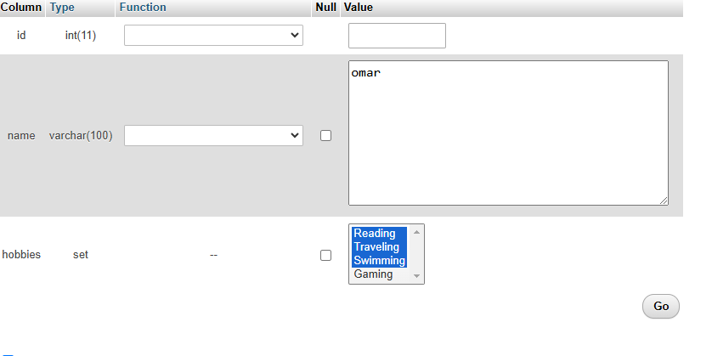

Deal with databases
Creating a Database (if it does not exist):
CREATE DATABASE IF NOT EXISTS database_name;

Dropping a Database (if it exists):
DROP DATABASE IF EXISTS database_name;

Showing All Databases:
SHOW DATABASES;

Using a Specific Database:
USE database_name;

Showing All Tables in a Database:
SHOW TABLES;

Show database like:
SHOW DATABASES LIKE 'pattern';
Example :
to show databases that contain the word "test" anywhere in their name, you can use:
sql
SHOW DATABASES LIKE '%test%';

Qu : Where database stored in our system :

Database Storage :

- Each subdirectory within c:\xampp\mysql\data corresponds to a database. The name of the subdirectory is the same as the database name.

- Inside each database subdirectory, you’ll find various files representing tables and metadata.

File Types
- .opt:
  - Purpose: This file contains configuration options specific to a particular database.
  - Analogy: It's like a settings file for a video game, where each game might have its own preferences.
- .frm:
  - Purpose: This file stores the schema or structure of a table, such as column names and data types.
  - Analogy: Think of it as the blueprint of a house, detailing the design and layout.
- .ibd:
  - Purpose: This file holds the data and indexes for tables using the InnoDB storage engine.
  - Analogy: It's like a storage room that not only keeps all the items (data) but also includes a catalog (indexes) for organizing and finding those items quickly.
Simplified Summary:
- .opt: Settings file for a database.
- .frm: Blueprint of a table (table structure).
- .ibd: Storage room for InnoDB table data and indexes.

Configuration:
- You can change where data is stored by editing the MySQL configuration file.

Deal with Tables

Creating a Table :
You can create a table with specific columns and data types
CREATE TABLE IF NOT EXISTS users (
id INT AUTO_INCREMENT PRIMARY KEY,
name VARCHAR(100),
email VARCHAR(100) UNIQUE,
created_at TIMESTAMP DEFAULT CURRENT_TIMESTAMP
);

IF NOT EXISTS: Ensures the table is only created if it doesn't already exist.

Showing Table Structure :
To see the Structure of a table
DESCRIBE users;
This command displays the columns, their data types, and other attributes.

Inserting Data:
Add new rows to your table.
INSERT INTO users (name, email)
VALUES ('Alice', 'alice@example.com'),
('Bob', 'bob@example.com');
- INSERT INTO: Specifies the table and columns.
- VALUES: Lists the data for each row.

Selecting Data:
Retrieve data from your table.
SELECT * FROM users;
SELECT: Chooses the columns to display (* means all columns).
FROM: Specifies the table.

Updating Data:
Modify existing data in your table.
UPDATE users
SET email = 'newalice@example.com'
WHERE name = 'Alice';
- UPDATE: Specifies the table to update.
- SET: Lists the columns and new values.
- WHERE: Specifies which rows to update.

Deleting Data:
Remove data from your table.
DELETE FROM users
WHERE name = 'Bob';
DELETE FROM: Specifies the table to delete from.
WHERE: Specifies which rows to delete.
Dropping a Table:
Remove a table and its data permanently.
DROP TABLE IF EXISTS users;
DROP TABLE: Deletes the table.
IF EXISTS: Ensures the command only runs if the table exists.

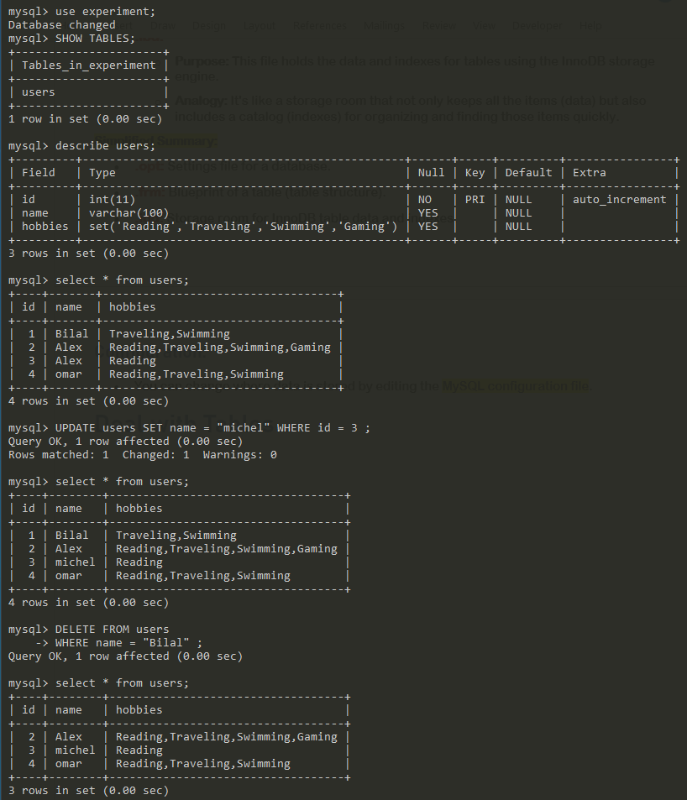

Show sql code
Using show + sql code , let ‘s see an example :

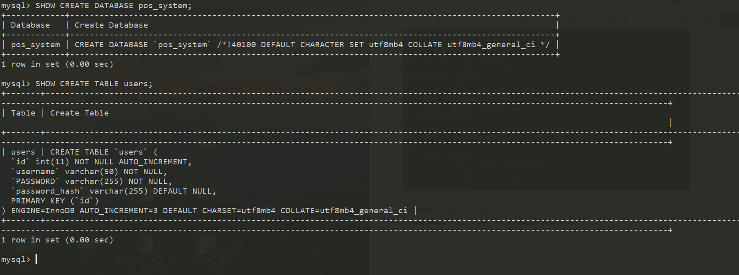

Show table status

To show table status .
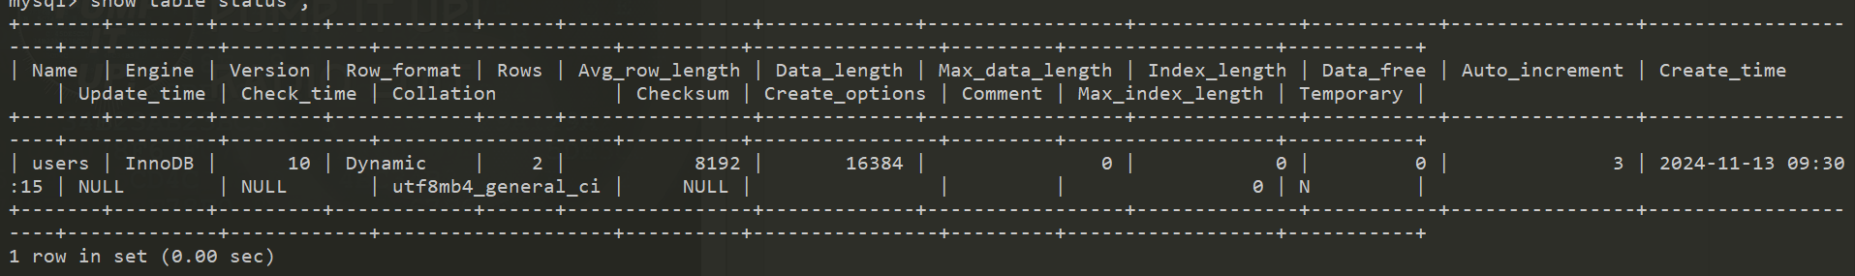

Rename Tab

Cli
To rename a Table in CLI , you have to do is : Rename Table
RENAME TABLE old_table_name TO new_table_name;
And also you can rename 2 tables in the same time
Just I will remid you how to create a table :
CREATE TABLE table_name (
column1 datatype constraints,
column2 datatype constraints,
...
columnN datatype constraints
);
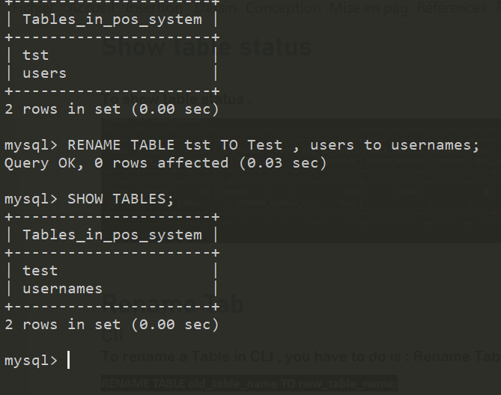

Phpmyadmin
A , To rename a table in phpmyadmin , all you have to do is to choose the table, and then press operation in the top navbar and then look for Talbe options
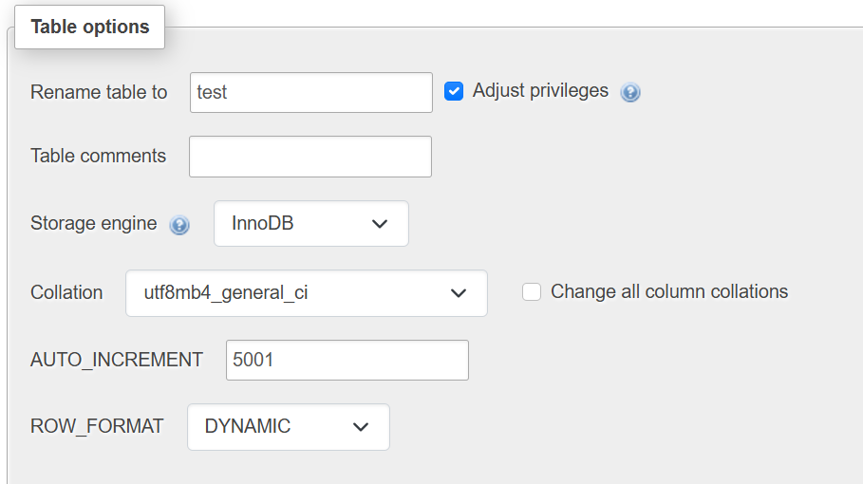

Storage engine change
And also here you can change the type of the storage engine
but what if we want to change it from CLI.
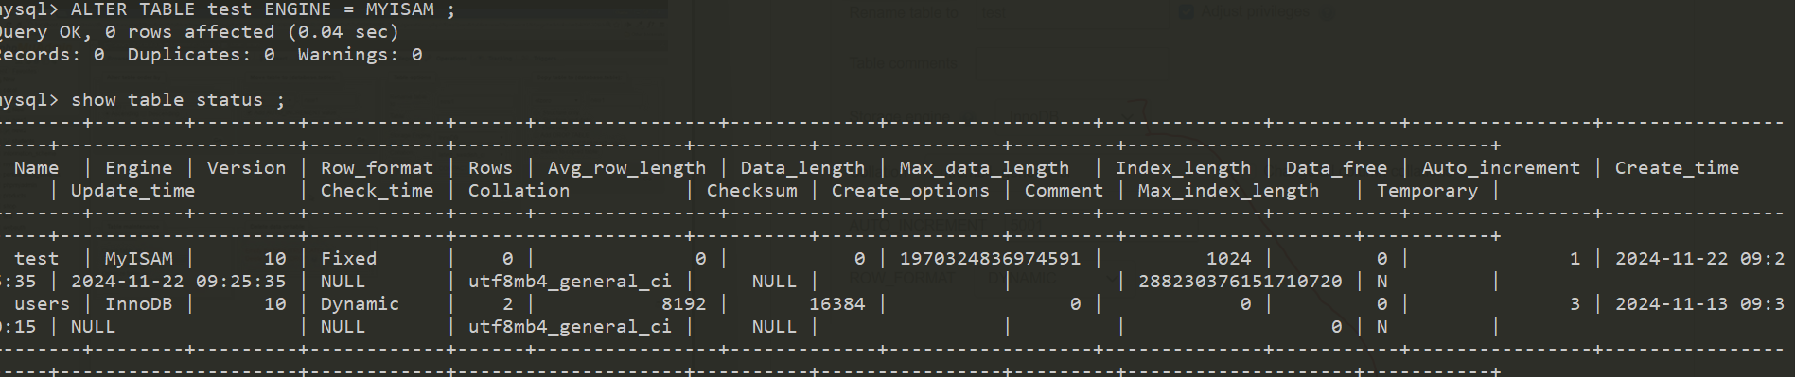
ALTER TABLE test ENGINE = MYISAM ;

ALTER
The ALTER keyword in SQL is used to modify an existing database object, such as a table.it’s a powerful tool that allows you to make chages to the structure of your tables and other database object without having to drop and recreate then. Here are some common operations you can perform using the ALTER statement .

Add a Column
You can add a new column to an existing table.
ALTER TABLE table_name
ADD column_name datatype;
Example :
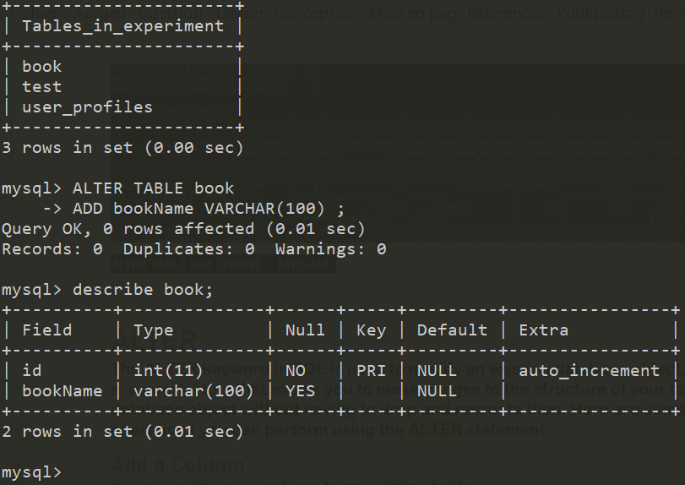

So as use the new table create goes at the end of the sentence.

How to control its position ?
To put as the end === do not be mad , hhhhhhh , this the default , you don’t have to add nothing .
To control the position of a new column when adding it to an exisiting table in MySQL, you can use the FIRST or AFTER existing_column Clauses in the ALTER TABLE statement. This allows you to specify exactly where the new colum should be placed within the table .

Adding a Column at the Beginning
To add a new column at the beginning of the table, use the FIRST keyword :
ALTER TABLE table_name
ADD column_name datatype FIRST;
Example :
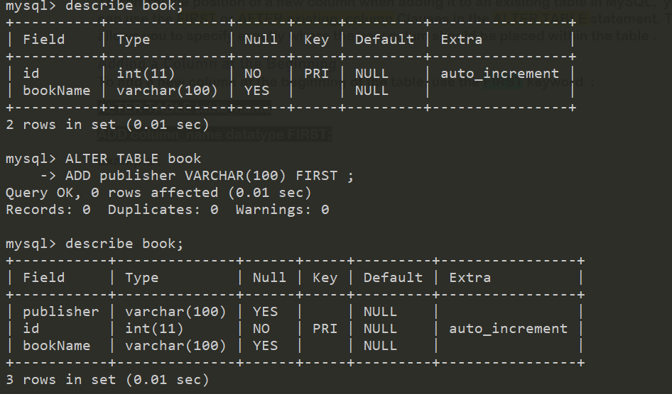

Adding a Column after a Specific Column
To add new column after a specific existing column, use the AFTER keyword :
ALTER TABLE table_name
ADD column_name datatype AFTER existing_column;
Example :
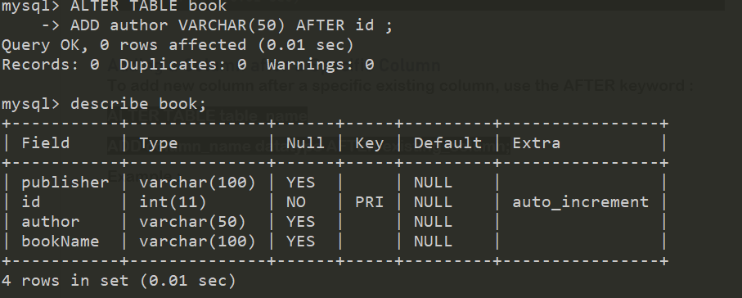

Control the position from phpmyadmin
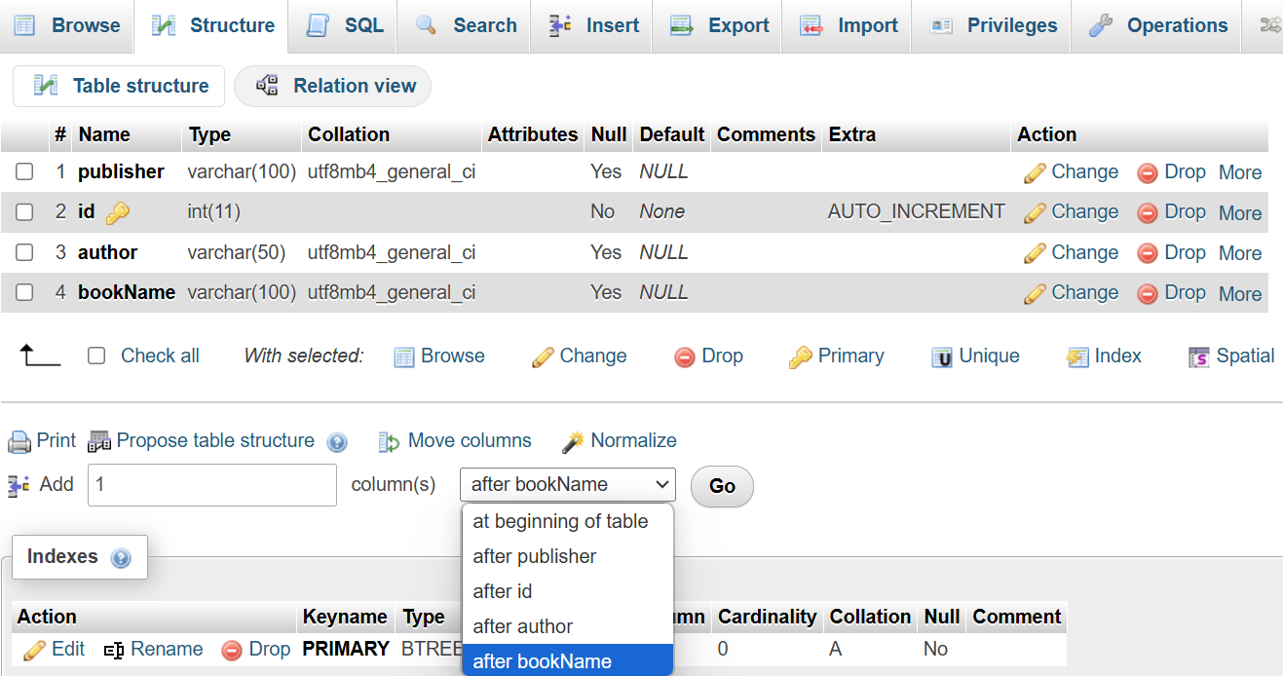

Drop a Column
You can remove a column from an existing table .
ALTER TABLE table_name
DROP COLUMN column_name;

Change
The CHANGE keyword in MySQL is used within the ALTER TABLE statement to rename an existing column or modify its definition. It allows you to change the column name, its data type, and optionally its constraints.
And most important Thing ========================= > its can move columns
Syntax :
ALTER TABLE table_name
CHANGE old_column_name new_column_name new_datatype;

Examples :

Renaming a Column and Changing its Data Type
If you wqnt ot rename a colum and change its data type, you can do the following :
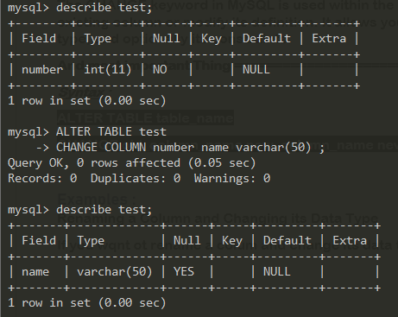

Adding Constraints While Changing
You can add constraints to a column while using CHANGE : (see example below )

Dropping Constraints
To drop a constraint, you would typically use a separate ALTER TABLE statement. For example, to drop a UNIQUE constraint :
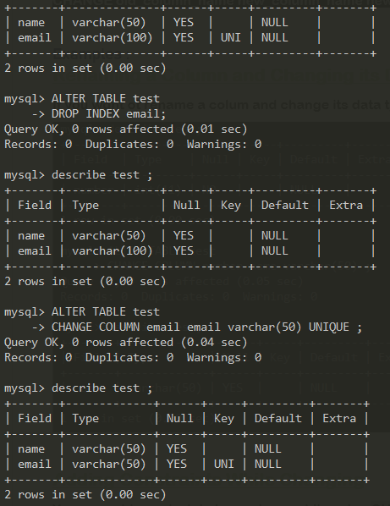

Moving a Column with Change
The CHANGE keyword can be sued to rename a column, modify it definition, and reposition it within the table.
---------------------------------------Syntax
ALTER TABLE table_name
CHANGE old_column_name new_column_name new_datatype AFTER
Or to move it to the first position
ALTER TABLE table_name
CHANGE old_column_name new_column_name new_datatype FIRST;

Moving a Column using PhpMyAdmin

All you have to do is selecting table then go to structure and then press move column , you get (like img below) now just drap and drop to reposition all :
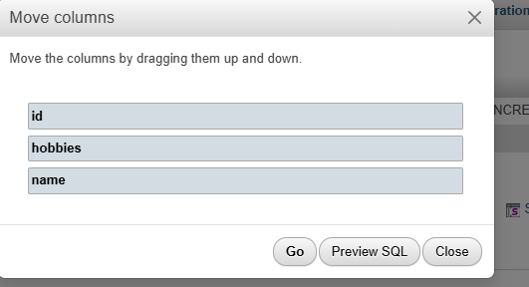

Rename a Table using ALTER

ALTER TABLE old_table_name
RENAME TO new_table_name;
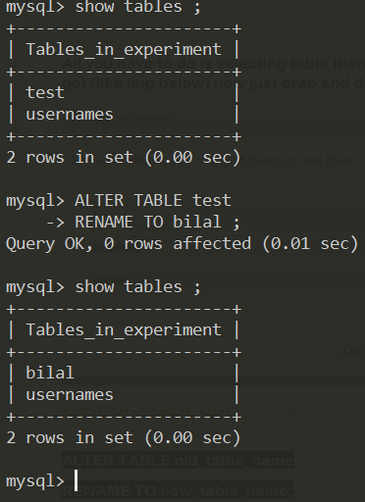

Alter Modify
The Key difference between MODIFY and CHANGE in MySQL’s ALTER TABLE statement lies in their functionality and use cases. Both are used to modify the structure of existing columns, but they differ in what exactly ther can alter
Note : alter == change

MODIFY
- What it does: You use MODIFY to change a column’s properties, like its data type or size, but you cannot change its name.
- When to use it : if you just want to adjust the type or attrubutes of a column, but the name stays the same ;
Example :
ALTER TABLE employees MODIFY COLUMN age SMALLINT;
- This Changes the column age from INT to SMALINT without changing its name ;

CHANGE
- What it does: You use CHANGE to rename a column and/or change it properties. It requires the old and new column names.
- When to use it : if you just want to rename a column and/or change it properties.
- Example :
ALTER TABLE employees CHANGE COLUMN age age_in_years SMALLINT;;
- This Changes the column age from age to age_in_years, and also changes its type to SMALLINT .

In short:
- Use MODIFY if you only want to change the column’s type or size but not its name.
- Use CHANGE if you want to rename the column and change its type or other properties.

Modify & change
You can use MODIFY and CHANGE in the same statement.
ALTER TABLE table_name
MODIFY COLUMN column_name column_definition,
CHANGE COLUMN old_column_name new_column_name new_column_definition;

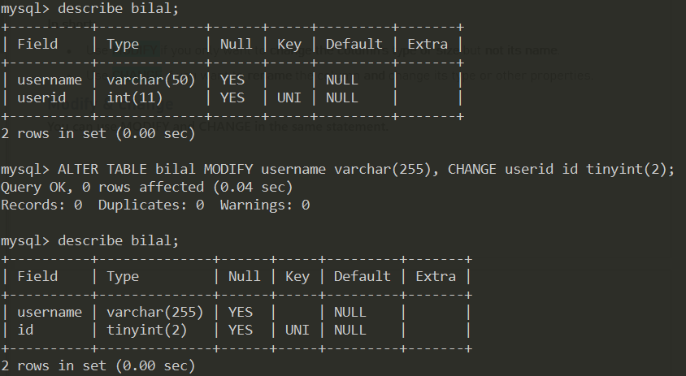

Constraint _ Intro
Constraints are rules that help ensure the intergrity and correctness of the data within a database. Constraints are applied to columns or tables to enforece conditions .
Here are the main types of constraints in MySQL, with their syntax and examples:

NOT NULL Constraint
Ensures that a Column cannot have a NULL value.
Syntax :
CREATE TABLE table_name (
column_name datatype NOT NULL
);
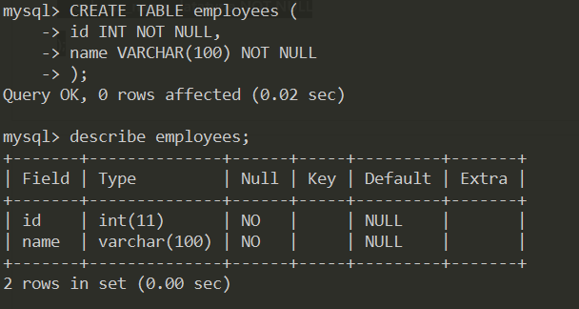

DEFAULT Constraint

Specifies a default value for a column when no value is provided during insertion.
Syntax:
CREATE TABLE table_name (
column_name datatype DEFAULT default_value
);
Example :
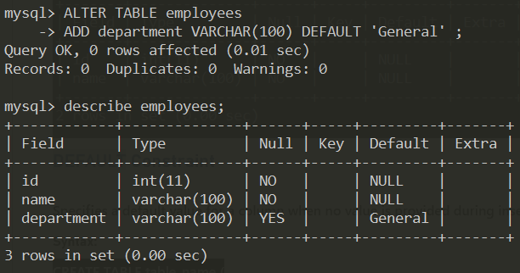
If no value is provided for department, it will default to ‘General’ ;

UNIQUE Constraint
Ensures that all values in a column (or combination of columns) are distinct across rows.
Syntax :
CREATE TABLE table_name (
column_name datatype UNIQUE
);
Example :
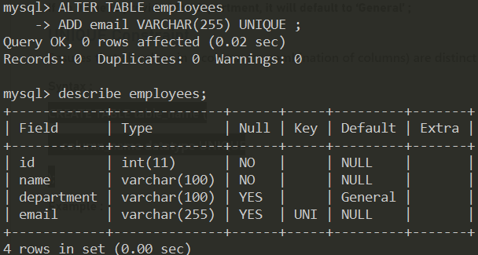

- The email column must have unique for every row in the table

PRIMARY KEY Contraint
Uniquely identifies each record in a table. A table can have one primary key. A primary key is a combination of NOT NULL and UNIQUE constraints.
Syntax :
CREATE TABLE table_name (
column_name datatype PRIMARY KEY
);

Example :
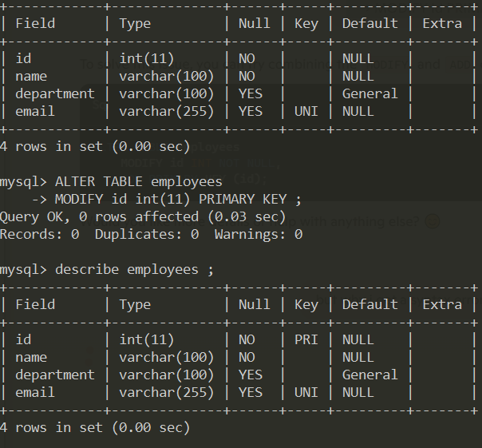

- The id column is the primary key, and it must be unique and not NULL
Note :
- Each table , can only have one primary key .
- You can make a column primary, by pressing Primary in structure on phpmyadmin, if the key silver, make that this column is primary.
- In phpmyadmin, if the primary key is already selected, and you make anohter column is primary, the new one will be primary and the first will be normal (meaning : not pri key )
- There 2 methods to make a coumn primary in cli or in query. The second you will see in add & drop constraint.

FOREIGN KEY Constraint
Enforces a link between the columns in two different tables. It ensures that a value in one table corresponds to a valid record in another table.
Syntax :
CREATE TABLE table_name (
column_name datatype,
FOREIGN KEY (column_name) REFERENCES other_table (other_column)
);
Example :
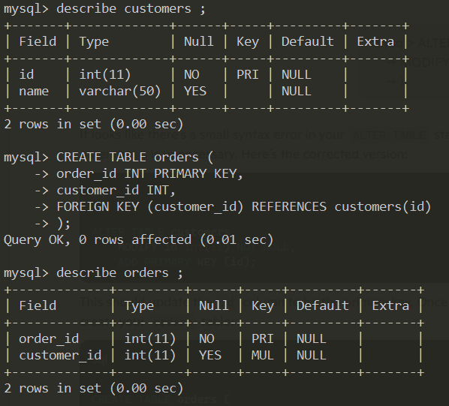
For that FOREIGN KEY work the two field must be PRIMARY KEY
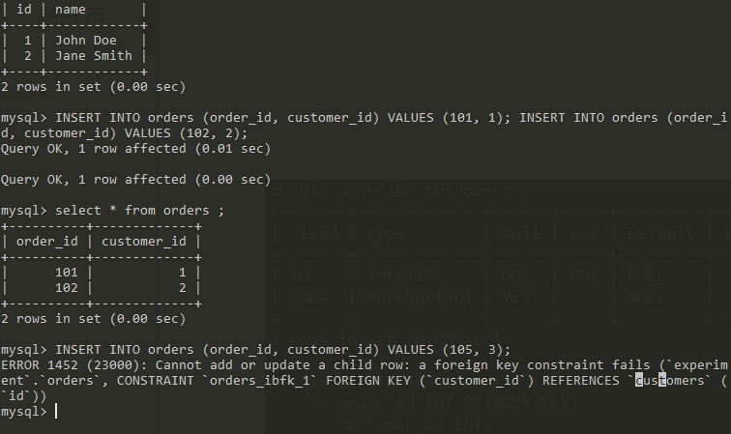

Summary :
      - Customers Table : Id is the primary key.
      - Orders Table: customer_id is a foreign key refrencing the id in the customers table.
      - Data Insertion : Customers and orders are added with refrences to ensure data integrity.
By setting up the tables and inserting data this way, we ensure that each order is linked to a valid customer.
I you see above, I try to add an order to a customer id that does not exisit in customers table, so I get an error .

CHECK

- Purpose : Ensures that all values in a column satisfy a specific conditon.
- Syntax :
CREATE TABLE table_name (
column_name datatype,
CHECK (condition)
);

Example :
Let’s create a students table with a CHECK constraint to ensure that the age of students is between 18 and 32.
CREATE TABLE table_name (
column_name datatype,
CHECK (condition)
);
Breakdown:
- student_id: Primary key that uniquely identifies each student.
- name: Student's name, which cannot be null.
- age: Student's age, which must be between 0 and 100, inclusive.
Inserting Data

mysql> describe students;
+------------+-------------+------+-----+---------+-------+
| Field | Type | Null | Key | Default | Extra |
+------------+-------------+------+-----+---------+-------+
| student_id | int(11) | NO | PRI | NULL | |
| name | varchar(50) | NO | | NULL | |
| age | int(11) | YES | | NULL | |
+------------+-------------+------+-----+---------+-------+
3 rows in set (0.00 sec)

mysql> INSERT INTO students (student_id, name, age ) VALUES ( 5 , 'bilal', 19 ) ;
Query OK, 1 row affected (0.01 sec)

mysql> INSERT INTO students (student_id, name, age ) VALUES ( 17 , 'Ahmad', 34 ) ;
ERROR 4025 (23000): CONSTRAINT `CONSTRAINT_1` failed for `experiment`.`students`
mysql>

The second insert statement will cause an error because the age value 34 does not satisfy the CHECK constraint ( age must be between 18 and 32 )
This is how the CHECK constraint can be used to enforce rules on the data entered into a table.

INDEX
- Purpose : Used to create and retrive data from database very quickly.
- Syntax
CREATE INDEX index_name
ON table_name (column_name);

Why use an index ?
An index is used to make data retrieval faster. Think of it like a book’s index. Without an index. If you want to find a specific topic in the book, you have to read through every page. With an index, ou can quicly jump to the right page.

How indexes work
Indexes work by creating a data stucturce (Usually a B-tree) that allows the database to search, sort, and filter data more efficiently. This sturcture is maintained separately from the actcual table data.

Pros and Cons of Indexes
Pros:
- Faster Data Retrieval: Significantly speeds up SELECT queries.
- Efficient Sorting: Speeds up ORDER BY and GROUP BY operations.
Cons:
- Slower Write Operations: Inserting, updating, or deleting data can be slower because the index also needs to be updated.
- Storage Space: Indexes require additional storage space.

Behind the Scenes of Creating an Index
- Data Structure Creation: When you create an index, the database creates a special data structure (usually a B-tree or a hash table). This structure organizes the indexed data for quick search.
- Index Entries: The database creates entries in the index for each row in the table. Each entry includes the value of the indexed column and a pointer to the actual row in the table.
- Sorted Order: The data in the index is stored in a sorted order. This sorted structure allows the database to perform quick lookups, similar to how a sorted list makes searching faster.

ADD & DROP A CONTRAINT
To add or drop constraints in SQL, we use ADD CONSTRAINT and DROP CONSTRAINT. Here’s quick summary:

Adding
Syntax:
ALTER TABLE table_name
ADD CONSTRAINT constraint_name
Constraint_type (column_name )

operation | SQL Command | Description
Add primary key | ALTER TABLE table_name ADD CONSTARINT pk_name PRIMARY KEY (column ) ; | Adds a prmary key constraint to a column
Drop primary key | ALTER TABLE table_name DROP PRIMARY KEY; | Drops the primary key constraint with specified actions.
Add foreing key | ALTER TABLE table_name ADD CONSTRAINT fk_name FOREIGN KEY (parent_column) REFERENCES parent_table (parent_column° [ON DELTE action ] [ON UPDATE action ] | Adds a foreign key constraint with specified action
Drop Foreign Key | ALTER TABLE table_name DROP FOREIGN KEY fk_name ; | Drop a foreign key
Add Unique | ALTER TABLE table_name ADD CONSTRAINT unique_name UNIQUE (column) ; | Adds a unique constraint to a column
Drop Unique | ALTER TABLE table_name DROP INDEX unique_name ; | Drops a unique constraint from the table.
Add Not Null | ALTER TABLE table_name MODIFY column datatype NOT NULL | Adds a NOT NULL constraint from the table;
Drop Not Null | ALTER TABLE table_name MODIFY coumn datatype NULL | Drops a NOT NULL constraint, allowing NULL values

MYSQL String Functions
MySQL have a large string functions that are incrdebily useful for manipulating and querying string data within you MySQL databases.

LEFT, RIGHT and MID

They are function to extract a number of caracters from a string .

LEFT
Returns the leftmost number of characters from a string.
Syntax :
LEFT ( String , Length )
Example :
mysql> select id , text , LEFT(text, 3 ) AS left_part , RIGHT(text, 3 ) AS right_part , MID(text , 2 , 3) AS mid_part
-> FROM test ;
+------+--------------+-----------+------------+----------+
| id | text | left_part | right_part | mid_part |
+------+--------------+-----------+------------+----------+
| 1 | Egypt | Egy | ypt | gyp |
| 2 | Morocco | Mor | cco | oro |
| 3 | Saudi Arabia | Sau | bia | aud |
| 4 | Quatar | Qua | tar | uat |
+------+--------------+-----------+------------+----------+
4 rows in set (0.00 sec)

mysql>

Length, Char_Length
The both calculate the length of a string .
Those function are so important , by example you can use them for sorting strings based on length by example from the shortest one to the longest one .
mysql> SELECT text, LENGTH(text) AS length_in_bytes, CHAR_LENGTH(text) AS length_in_characters, CHARACTER_LENGTH(text) AS character_length
-> FROM test ;
+--------------+-----------------+----------------------+------------------+
| text | length_in_bytes | length_in_characters | character_length |
+--------------+-----------------+----------------------+------------------+
| Egypt | 5 | 5 | 5 |
| Morocco | 7 | 7 | 7 |
| Saudi Arabia | 12 | 12 | 12 |
| Quatar | 6 | 6 | 6 |
+--------------+-----------------+----------------------+------------------+
4 rows in set (0.00 sec)

Length

LENGTH( ) : Returns the length of the string in bytes.

CHAR_LENGTH(text) and CHARACTER_LENGTH( ):
Both functions return the length of the string in characters. In MySQL CHAR_LENGTH and CHARACTER_LENGTH are synonymous .

Multibyte Characters
Multibyte Characters are used in various languages where characters cannot be represented by a single byte For example, UTF-8 enconding uses 1 to 4 bytes to represent characters. This is imporatnt for languages with large character sets, suc as chinese, Japnese, and Korean .
INSERT INTO test (id, text) VALUES (5, 'こんにちは'); -- "Hello" in Japanese
NOTE :
Insert in PHPMyAdmin , if you insert it these in terminal will not work
So in PHPMyAdmin :

SELECT text, LENGTH(text) , CHARACTER_LENGTH(text) , CHAR_LENGTH(text)
From test;
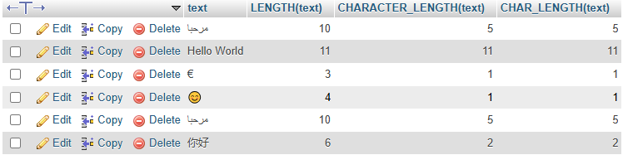
Make it more mangeable :
-- Step 1: Insert Unicode text INSERT INTO my_table (text) VALUES ('Hello World'), ('€'), ('😊'), ('مرحبا'), ('你好');
-- Step 2: Retrieve and check the data SELECT id, text, LENGTH(text) AS length_in_bytes, CHAR_LENGTH(text) AS length_in_characters FROM my_table;

Upper, Lower
They are 2 function that modify the Case of your stirng

UPPER( )
UPPER(string) and UCASE(string) are synonymous, the both require string
Let’s try it :
SELECT text, UPPER(text) , UCASE(text) FROM test WHERE id = 2;

LOWER( )
LOWER(string) and LCASE(string) are synonymous, the both require string
Let’s try it :
SELECT text, LOWER(text) , LCASE(text) FROM test WHERE id = 2;



Info
Since the lesson is too small , let’s make a sql command and display fileds from the tollest one to the shortest one .
Waaaaaaaaaaa drari ki jakom dars nadi wla lae : hhhhhhhhhhhhh (2024-12-12 )
Let’s make it :
SELECT text , CHAR_LENGTH(text) AS count FROM test ORDER BY count DESC;
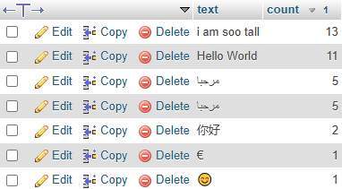

Repeat , Reverse , Replace

Syntax :

- REPEAT ( String , Number Of Repeats )
- REPLACE ( String , From , To )
- REVERSE ( String )

Try Them
SELECT text , REPEAT(text , 3 ) AS Repeated FROM testing;
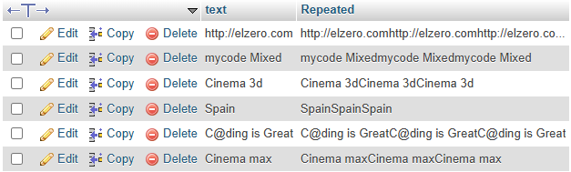

NOTE :
You don’t use these functions just in select you can do perfect work with them , by example : use them in update
UPDATE testing SET text = REPLACE(text, 'http', 'https') WHERE id = 1;
Now reverse :
SELECT text , REVERSE(text) AS Reversed FROM testing;
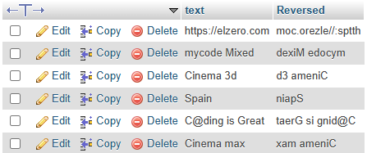

Concat, Concat_Ws

Def
CONCAT concat join two string
CONCAT_WS concat with seperator join two string

Syntax :
CONCAT ( String, String , ……….. , String)
CONCAT_WS ( Seperator , String, String )

Let’s try Them
SELECT text , CONCAT( text ," " , "Added By Me") AS CONCATED From testing;
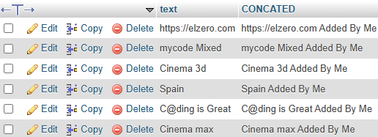

Let’s make something more significante :
SELECT id ,
name ,
CONCAT('The Country Is ' , name , ' And Its ID Is ' , id ) AS mytext
FROM country;
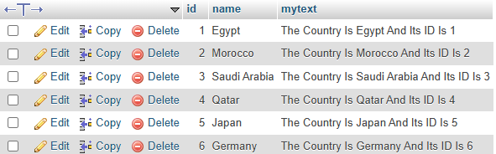
Help :
CREATE TABLE country (
id INT AUTO_INCREMENT PRIMARY KEY,
name VARCHAR(50) NOT NULL
)

INSERT INTO country (name) VALUES
('Egypt'),
('Morocco'),
('Saudi Arabia'),
('Qatar'),
('Japan'),
('Germany');
Let’s try concatination with seperator
SELECT CONCAT_WS(' : ' , 'Country' , name) AS myTextWithSeperator from country;
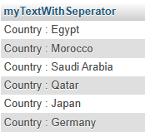
What if we give the function just the seperator and just one other arg.
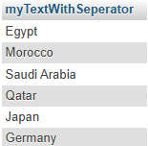
As you see there is no seperator , because as it name indicate it a seperator that seperat two thing, and in this case there is one thing, so there is nothing to be seperated .

Example of both
SELECT CONCAT_WS(' ==> ', CONCAT(id , " ") , name) AS myTextWithSeperator
from country;
using concat_ws and repeat repeat and seperat with a seperator .

Insert
The INSERT string function is used to modify a string by inserting, repelacing, or appending characters into it . Here’s how it works and how you example applies :

Syntax:
INSERT ( String , Position , Length , New String )
  - String :
- The string you want to modify
- This can be a column value (e.g name ) or a literal string (e.g , ‘Hello’)

  - Position :
- This the 1-based index in string where the insertion begins.
- For example, a position of 1 mean s the insertion start at the verty first character of the string.
- Length :
- This parameter specifies the number of characters to delete from string starting at position .
- If length is set to 0, no characters are deleted, and the new string is inserted at the specified position
- New_string :
- This is the string that you want to inset into string .

Example :
SELECT name , INSERT(name, 4 , 0 , " is Beautiful ") AS edited FROM `country`;
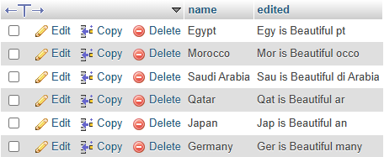
As you see , we don’t delete anything .
let’s starat delting by using length paramter :
just let’ make an other table to more be good :
SELECT name , INSERT(name , 4 , 5 , " -Serial- ") AS Edited FROM serial;
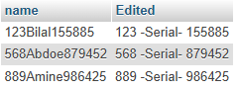

Practice :
We added also id to this table:
SELECT id , name , INSERT(name, 4 , 11 , CONCAT(" -Serial -", REPEAT("#" , 6 ) , id ))
AS HASHED
FROM serial;

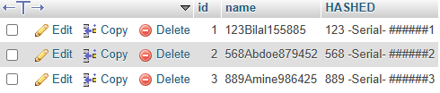

TRIM , LTRIM, RTRIM

Syntax :
TRIM ( METHODS [ Leading | Trailing | Both ] [Remove String] FROM [String] )
  - Methods
- Methods Optional If Not Written Both Will Be Used
- LEADING : Removes Characters frm the beginning of the string
- TRAILING : Removes Characters from the end of the string .
- BOTH : Removes characters from both sides (default behavior) .

- Remove String
      - Remove String If Not Written Space Will be Removed .

Example :
SELECT name , TRIM(name) from serial;



As you have saw in the last example , we use all the default behaviour of TRIM
Now let’s use also the other params :

Example using Methods :

SELECT name ,
TRIM(LEADING 'X' FROM name) AS 'LEADING',
TRIM(TRAILING 'X' FROM name) AS 'TRAILING',
TRIM('X' FROM name) AS 'BOTH'
FROM serial;

Practical Use Cases :
- Clean Up Data: Remove unwanted spaces from user input:
UPDATE users SET username = TRIM(username);

- Standardize Data: Clean leading and trailing characters for consistency:
SELECT TRIM('/' FROM '/path/to/file/') AS clean_path;
-- Output: 'path/to/file'

LTRIM
The LTRIM( ) removes spaces from the beginning (left side) of the string .
Syntax:
LTRIM(string)

RTRIM
The RTRIM( ) removes spaces from the end (right side ) of the string .
RTRIM(string)
Note :
Trim, LTRIM , RTRIM == are case sensitive

LPAD , RPAD

These functions are useful for formatting strings, especially when you need fixed-length output or need to align strings in a consistent manner. بطريقة متسقة
LPAD and RPAD are string functions in MySQL that allow you to pad a string with another string to a specified length, either on the left (LPAD) or on the right (RPAD).

LPAD (Left Pad )
The LPAD() function pads the stirng with a specified character (or substring) on the left side until it reacheds the desired lenfth .
Syntax :
LPAD(string, length, pad_string)
      - String : The original string that you want to pad
      - Length : The total lenfth of the resulting string (after padding)
      - Pad_string : The string that will be used for padding. It will be repeated if needed to reach the desired length .

RPAD (Right Pad )
The same as leff pad , please read above

Example :
Scenario: Invoice Number Generation
- Imagine you're working for a company that generates invoices, and you need to ensure that every invoice number has a fixed length (e.g., 10 characters), regardless of how many digits the number actually contains. In such cases, you can use padding to ensure the invoice number always appears in a consistent format.
Example:
- Let’s say the company generates invoice numbers like 1234, 56789, and 12. You want all invoice numbers to have a fixed length of 10 characters, and the missing digits will be padded with leading zeros (0).
- You can use LPAD to achieve this. ‘’’’’’’’’’’’’’’’’’’’’’’’’ invoice = facture

SELECT invoice_number , LPAD(invoice_number, 10 , '0') AS padded_invoice_number FROM invoice;

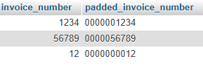

In this case , the LPAD funciton adds leading zeros to the invoice number so that it always has length of 10 characters .
Note:
Imagine that the text_provided’ length is 7 , the length desired is 5 .
So here LPAD will cut from the string .
SELECT invoice_number ,
LPAD(invoice_number, 2 , '0') AS padded_invoice_number
FROM invoice;
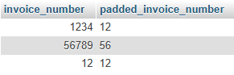

Numeric Functions

CEIL, FLOOR, and ROUND
In SQL, CEIL, FLOOR, and ROUND are mathematical functions used to manipulate numbers by rounding or returning specific values. Here’s a simplified explanation :

Ceil
- Description : Retunrs the smallest integer greater than or equal to a number.
- Use : Used for “rounding up”
- Syntax :

CEIL(number)

- Example :
SELECT number , CEIL(number) FROM `try`;

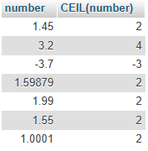

Floor
- Description: Returns the largest integer less than or equal to a number
- Use : Used for “rounding down”
- Syntax:
FLOOR(number)
Example :
SELECT number , FLOOR(number) FROM try;
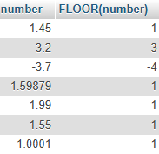

Round
- Description : Ronds a number to a specified number of decimal places .
- Use : Usefull for limiting numbers to specific decimals.
- Syntax :
ROUND(number, decimal_places)

- Example :

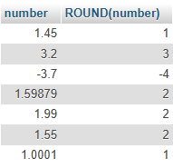
SELECT number , ROUND(number) FROM try;
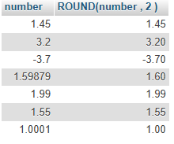
SELECT number , ROUND(number , 2 ) FROM try;

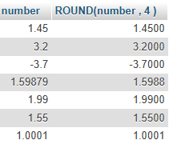

SELECT number , ROUND(number , 4 ) FROM try;

Let’s see how it works :
Round(1.599,2) since we have more than 2 decimal, so we have to make them just 2. So always we take the number after the last one, if it more or equal 5 => we round up , if not we round down .
In this cas more than 5 , so we round up , 9 bacome 10 , so the next 9 also become 10 and next one also , then 5 + 1 = 6 .
So the result is : 1.60
It necessary to add 0 , because the number desired of decimals is 2 .

MOD, Truncate, Pow

MOD
- Description : Returns the remainder of a division
- Use : Useful to determine if a number is divisible by another or for cyclic operations .
- Syntax :
MOD(number1, number2)

- Example :
SELECT MOD(10, 3); -- Result: 1 (10 ÷ 3 = 3 remainder 1)
SELECT MOD(15, 5); -- Result: 0 (15 ÷ 5 = 3 remainder 0)
SELECT MOD(-10, 3); -- Result: -1 (Sign follows the dividend)

TRUNCATE
- Description : Trims a number to a specified number of decimal places without rounding .
- Use : Useful for precise calculations where rounding is not needed.
- Syntax :

TRUNCATE(number, decimal_places)

- Example :
SELECT TRUNCATE(3.14159, 2); -- Result: 3.14
SELECT TRUNCATE(123.456, 0); -- Result: 123
SELECT TRUNCATE(-123.456, 1); -- Result: -123.4

POW (or POWER)
- Description : Raised a number to the power of another number (exponentiation)
- Use : Commonly used for mathematical calculations involving powers.
- Syntax :

POW(base, exponent)
-- or
POWER(base, exponent)

- Example :

SELECT POW(2, 3); -- Result: 8 (2³ = 8)
SELECT POWER(5, 2); -- Result: 25 (5² = 25)
SELECT POWER(9, 0.5); -- Result: 3 (square root of 9)

Key Differnces :
- MOD: Deals with remainders.
- TRUNCATE: Cuts off decimals without rounding.
- POW: Calculates exponential powers.

Date Functions

CURTIME , CURDATE, NOW

CURTIME ( )

- Description : Returns the current time (hours , minutes , seconds) in HH:MM:SS format.
- Use : Useful when you need only the time, not the date.
- Synonyms :
  - CURRENT_TIME ( )
  - CURRENT_TIME

- Example :
SELECT CURTIME();
SELECT CURRENT_TIME;
SELECT CURRENT_TIME;
SELECT CURRENT_TIME();
The output example : 10:49:18

CURDATE
Retruns the current date (YYYY-MM-DD) .
SELECT CURRENT_DATE;
The output example : 2024-12-16
- Synonms :
CURRENT_DATE ( )
CURDATE ( )

The output example : 2024-12-16

CURRENT_TIMESTAMP , NOW

Return : The current date and time in YYYY-MM-DD HH:MM:SS

Which one to Use ?

- Use CURRENT_TIMESTAMP if you want your SQL to work across multiple database systems.
- Use NOW() for MySQL or PostgreSQL when writing code specifically for those databases.
Example :
SELECT CURRENT_TIMESTAMP , CURRENT_TIMESTAMP() , NOW();
Example output : 2024-12-16 11:18:04

DAYNAME, DAYOFMONTH, DAYOFWEEK , DAYOFYEAR

DAYNAME(date)
- Definition : Returns the name of the day for a given date (e.g, “Monday”, “Tuesday”)

- Example :

SELECT DAYNAME(“2024-12-16”); --output: Monday
LET’S make it auto :
SELECT DAYNAME(CURRENT_DATE);

DAYOFMONTH ( date )

- Definition : Retunrs the day of the month from from a given date (1-31)
- Synonym : DAY()

- Example :

SELECT DAYOFMONTH('2024-12-16');
Or use synonym
SELECT DAY('2024-12-16');
Or make it auto
SELECT DAYOFMONTH(CURRENT_DATE);

DAYOFWEEK (date)

- Definition : Retunrs the weekday index for a given date (1 = Sunday , 2=Monday, …… 7 = Saturday)

- Example :
SELECT DAYOFWEEK(CURRENT_DATE);
Output : 2 ( Since 2 represent Monday )

DAYOFYEAR( date)
- Definition : Returns the day of the year (1-366) for a given date.
- Example

SELECT DAYOFYEAR(CURRENT_DATE);

OUTPUT : 352

Notes:
- DAYNAME returns a string with the full weekday name (e.g., "Monday").
- DAYOFMONTH returns just the numeric day of the month.
- DAYOFWEEK returns an integer where 1 represents Sunday.
- DAYOFYEAR returns the ordinal day of the year (1 for January 1st, 366 for December 31st in a leap year).

HOUR, Minute, Second , MONTH , MONTHNAME ..

HOUR( )
- Definition : Extracts the hour (0-23) from a time or datetime.
- Example :
SELECT HOUR(CURRENT_TIME);
Output : 0 (because now it , tnach d lil a m3alm)

MINUTE ( )
- Definition: Extracts the minute (0-59) from a time or datetime.
- Example :
SELECT MINUTE(CURRENT_TIME) AS MinutePart;

SECOND ( )
- Definition : Extracts the second (0-59) from a time or datetime.
- Example :
SELECT MINUTE(CURRENT_TIME) AS SecondPart;

YEAR ( )
- Definition: Extracts the year from a time or datetime.
- Example :
SELECT YEAR(NOW()) ;

MONTH ( )
- Definition: Extracts the month (1-12) from a time or datetime.
- Example :
SELECT MONTH(NOW());

MONTHNAME ( )
- Definition: return the full name of the month (e.g, “junuary”, “February”).
- Example :
SELECT MONTHNAME(NOW()) AS month_name;
Output : December

TIME( )
- Definition : Extracts only the time part from a datetime value .
- Example :
SELECT TIME('2024-12-16 15:45:30') AS TimeOnly;
Output : 15:45:30
SELECT NOW() , TIME(NOW()) AS TimeOnly;


DateDiff & Examples :

DATE_DIFF( )
- Definition: Calculates the difference in days between two dates
- Syntax :
DATEDIFF(date1, date2)
- Date1 : End date
- Date2 : Start date
As I said the DATE_DIFF retunr the diff , in days so it is ignore time, but you can enter a datetime as an argument in date1 or date2 but it gonna be ignored .
SELECT id , name , date ,
CONCAT("Registerd ",DATEDIFF(NOW(), date), " Days Ago") As regestration_duration
FROM `regestration`;
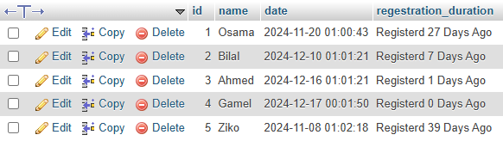

Note :
Focus , always choose DATETIME datatype , so that have enough info to manipulate date as you want , using the function above .

DATE_ADD , DATE_Sub

LAST_DAY
To get the last day of a month in MySQL , use this :
SELECT LAST_DAY('2024-12-15') AS last_day;
It will show 2024-12-31 (The last day of December )
We can use DAY_NAME to detect what its name .

DATE_ADD
To add a specific number of days to a date in MySQL, you can use the DATE_ADD() function. Here’s the basc syntax :
DATE_ADD(date, INTERVAL value unit)
- Date : The date to which you want to add days
- Value : The number of days (or other unit) you want to add.
- Unit : The time unit (in this case , DAY )

Example : add days to Current Date
If you want to add, for example, 10 days to the current date :
SELECT DATE_ADD(CURDATE(), INTERVAL 10 DAY);
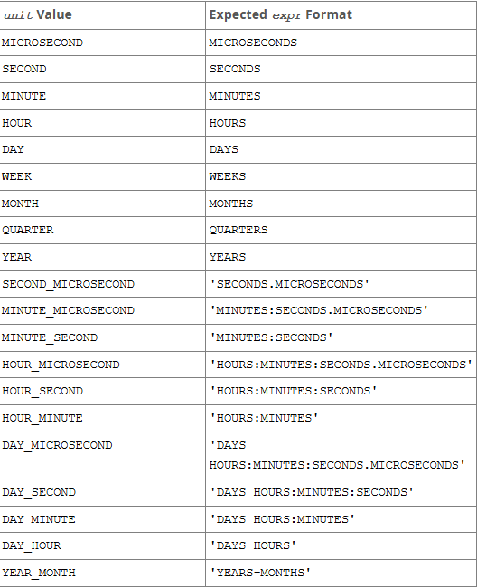

DATE_SUB
The same concept and it substract instead of add .
UPDATE regestration SET date = DATE_SUB(date, INTERVAL 3 MONTH);

COMPARISON FUNCTIONs

BETWEEN and NOT BETWEEN
The BETWEEN operator in MySQL is used to filter data by checking if a value is withing a specified range (inclusive of both ends). It works for numbers, dates, and even text values .
Syntax
Value BETWEEN low AND high
- Value : The column or expression you want to check .
- Low : the starting of the rang .
- High : the ending value of the range .
Example 1 : Numeric Range
To find all rows where an id column value is between 2 and 4
SELECT * FROM `regestration` WHERE id BETWEEN 2 AND 4;

Example 2 : Date Range
To find all rows where a date column is within a specific range .
SELECT * FROM regestration WHERE date BETWEEN '2024-05-17' AND '2024-09-17';
All the table:
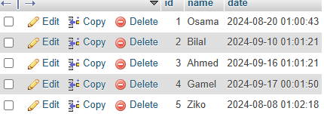
The result table :
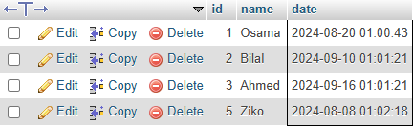
Focus on Gamal , he is excluded because of time , although the date in included .

NOT BETWEEN
I think now, you can now what NOT BETWEEN mean
SELECT *
FROM table_name
WHERE column_name NOT BETWEEN 10 AND 20;
This returns all rows where column_name is less than 10 or greater than 20.

IN
The IN and NOT IN operator in MySQL are used to filter rows based on whether a value mathces any value in a specified lis. These operators simplify queries with multiple OR conditions.
The IN operator checks if a value exists within a given list .
Syntax :
Value IN ( value1, value2, value3, ….)
Example 1 : Numeric Values
To find rows where number is 20,30,40
SELECT *
FROM `regestration`
WHERE number IN (10,30,50);

